

**PLEASE NOTE on December 6, 7 and 8th, 2023**

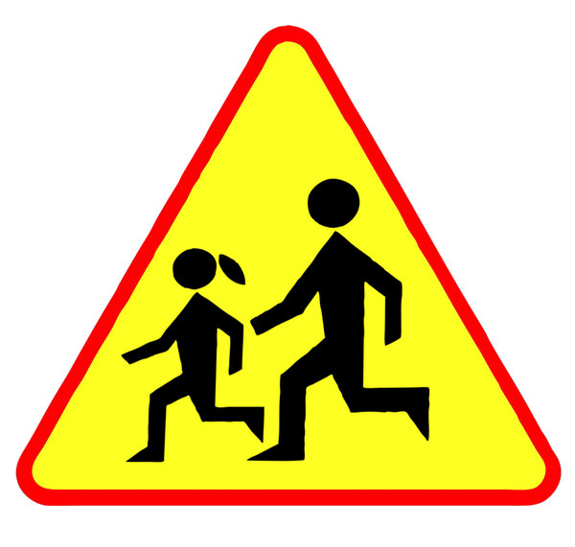

There will be no crossing guard at Domville and Eliza St in the afternoon.

Please use caution when crossing and when driving.